Character of King David as a Father
Pastor Yoo Nam Kang
1Chronicles 29:19
1Chronicles 29:19
Give my son Solomon the wholehearted desire to obey all your commands, laws, and decrees, and to do everything necessary to build this Temple, for which I have made these preparations.”

1. Called Solomon “son”
1Chronicles 29:19
Give my son Solomon the wholehearted desire to obey all your commands, laws, and decrees, and to do everything necessary to build this Temple, for which I have made these preparations.”
2Samuel 18:5
And the king gave this command to Joab, Abishai, and Ittai: “For my sake, deal gently with young Absalom.” And all the troops heard the king give this order to his commanders.
Ephesians 6:1-3
1 Children, obey your parents because you belong to the Lord, for this is the right thing to do. 2 “Honor your father and mother.” This is the first commandment with a promise: 3 If you honor your father and mother, “things will go well for you, and you will have a long life on the earth.”
2.Prayed that the son would be able to obey God’s commands, laws, and decrees
1Chronicles 29:19
Give my son Solomon the wholehearted desire to obey all your commands, laws, and decrees, and to do everything necessary to build this Temple, for which I have made these preparations.”
Matthew 15:4
For instance, God says, ‘Honor your father and mother,’ and ‘Anyone who speaks disrespectfully of father or mother must be put to death.’
Deuteronomy 27:16
‘Cursed is anyone who dishonors father or mother.’ And all the people will reply, ‘Amen.’
Proverbs 23:22
Listen to your father, who gave you life, and don’t despise your mother when she is old.
3. Prayed that his son would establish the temple
1Chronicles 29:19
Give my son Solomon the wholehearted desire to obey all your commands, laws, and decrees, and to do everything necessary to build this Temple, for which I have made these preparations.”
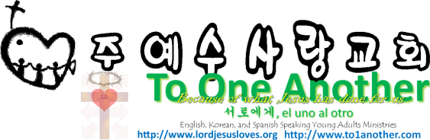
Ephesians 1:22-23
22 God has put all things under the authority of Christ and has made him head over all things for the benefit of the church. 23 And the church is his body; it is made full and complete by Christ, who fills all things everywhere with himself.

